**Nama:** Ian Mulya Chiuandi  
**NIM:** 2702218891  
**Kode Kelas:** BY01

**HCI Bluejack Project Documentation Document, Asset Link References, and Application Description**

**All Pages of “DiamondCut Motors”**

**A) Figma:**

* **Home Page**

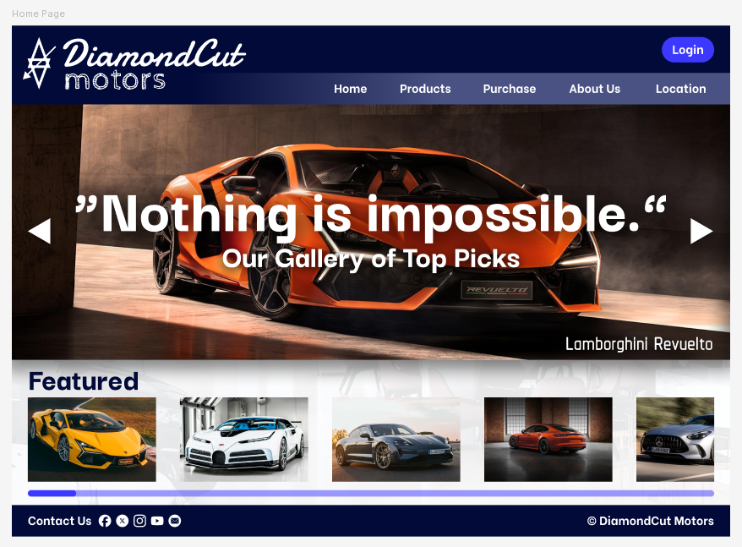

* **Cars Page**

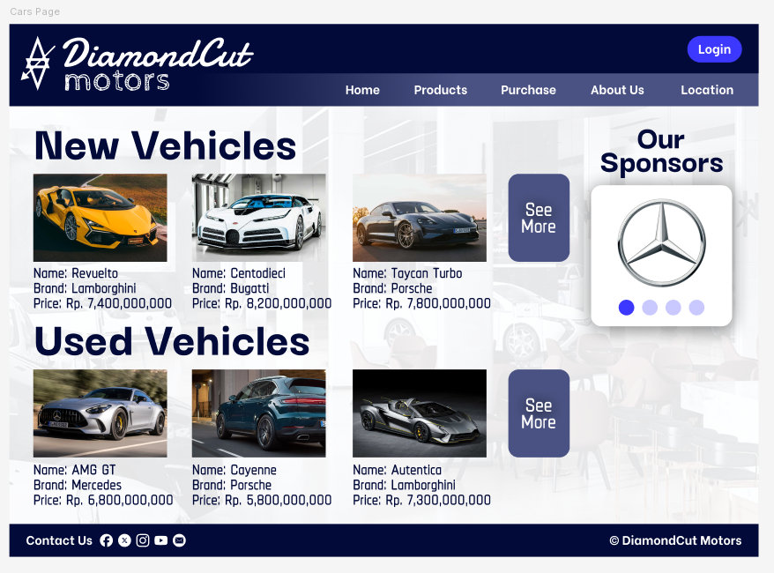

* **About Us Page**

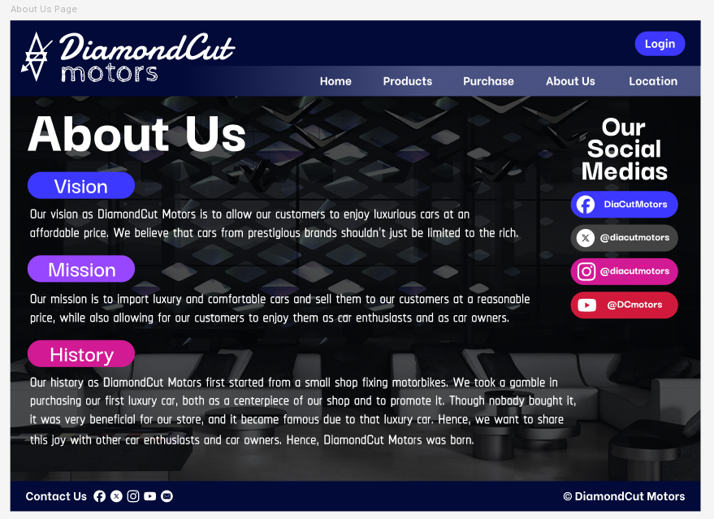

* **Locations Page**

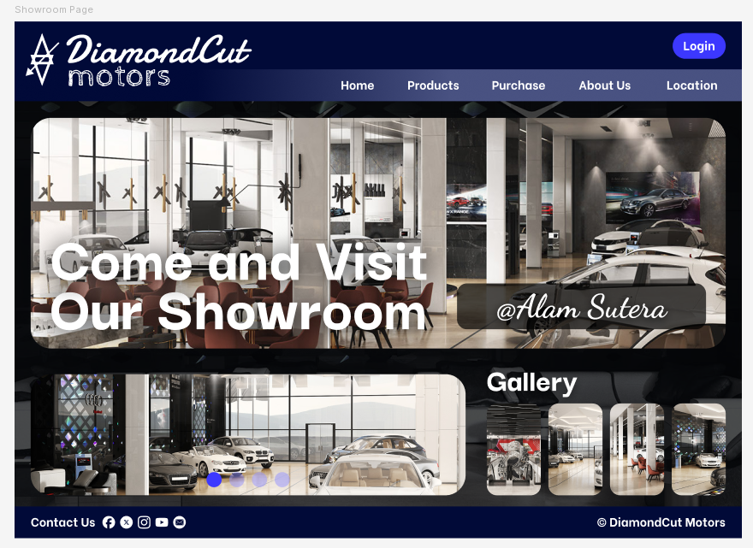

* **Login Page**

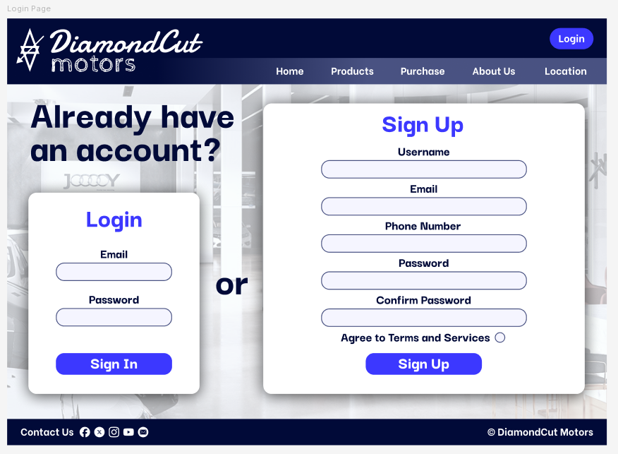

**B) Actual Website:**

* **Home Page**

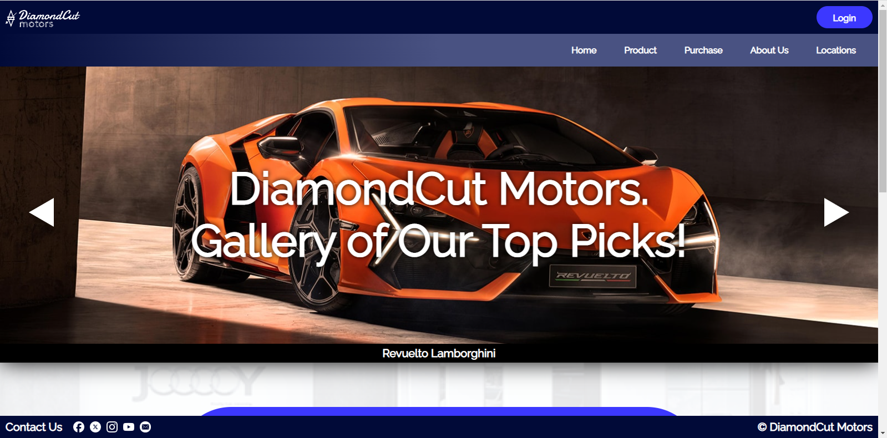

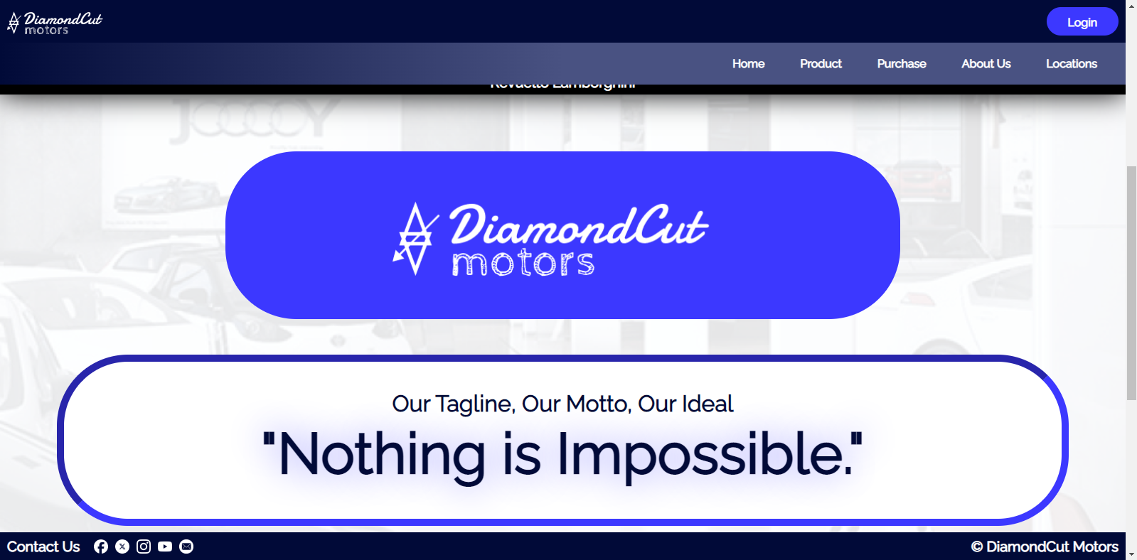

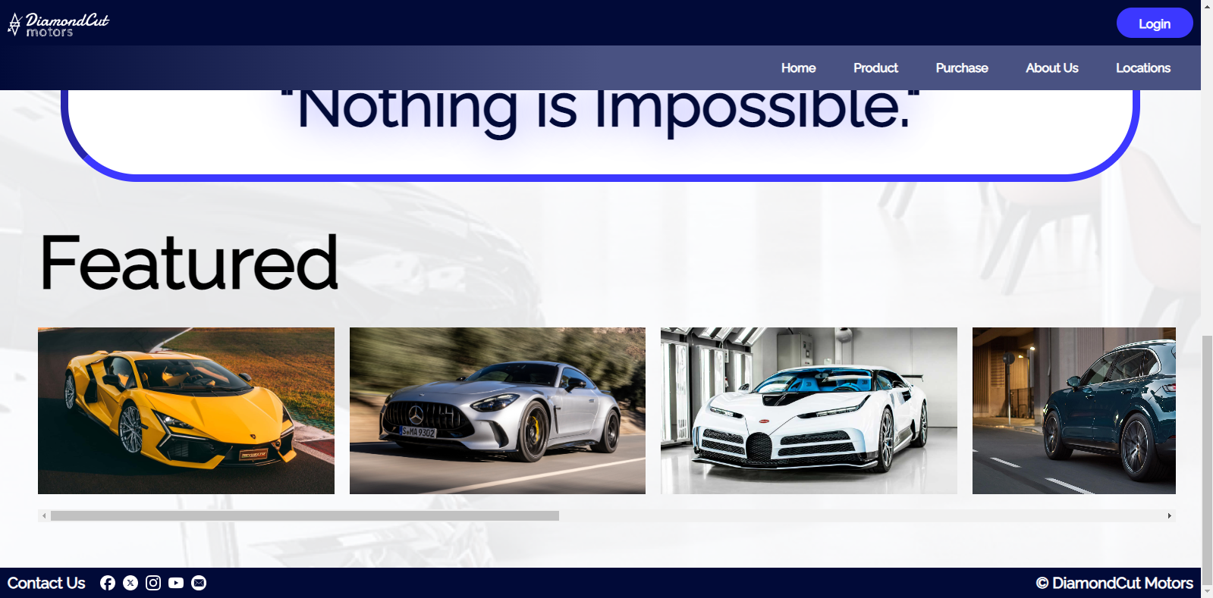

* **Cars Page**

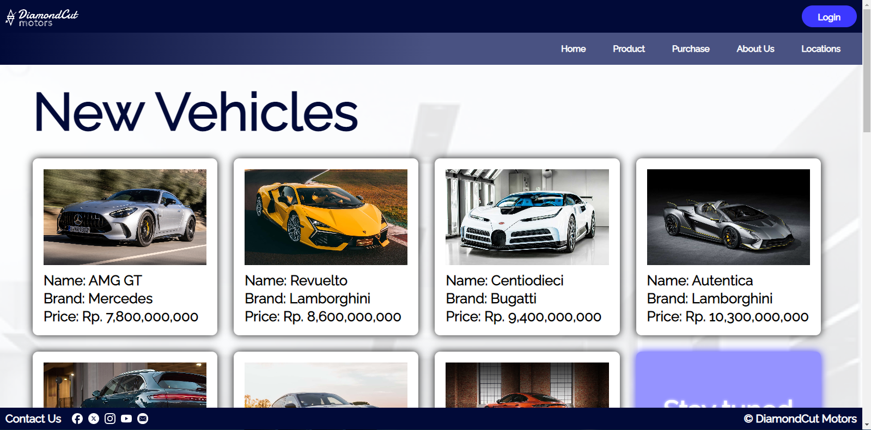

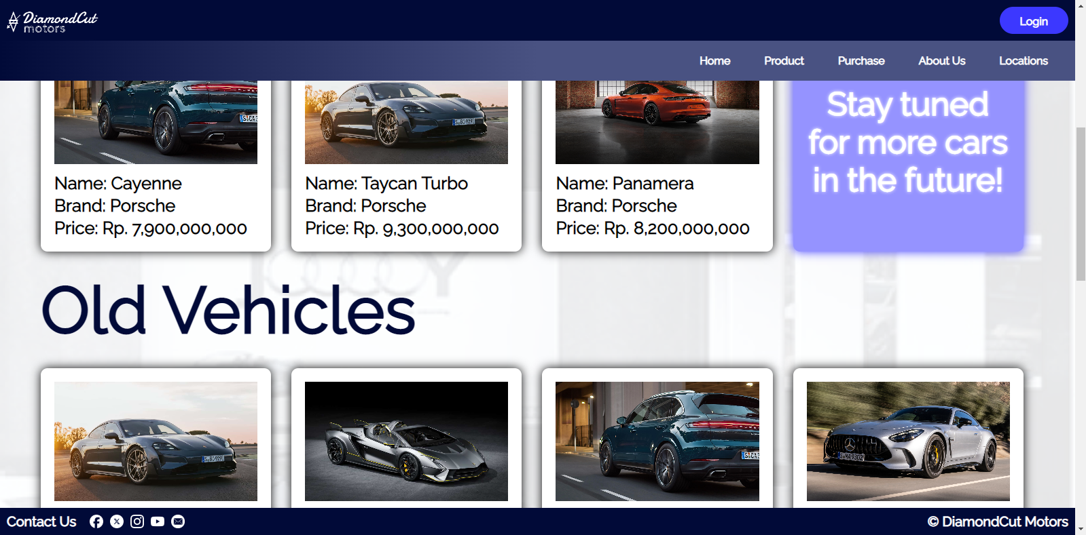

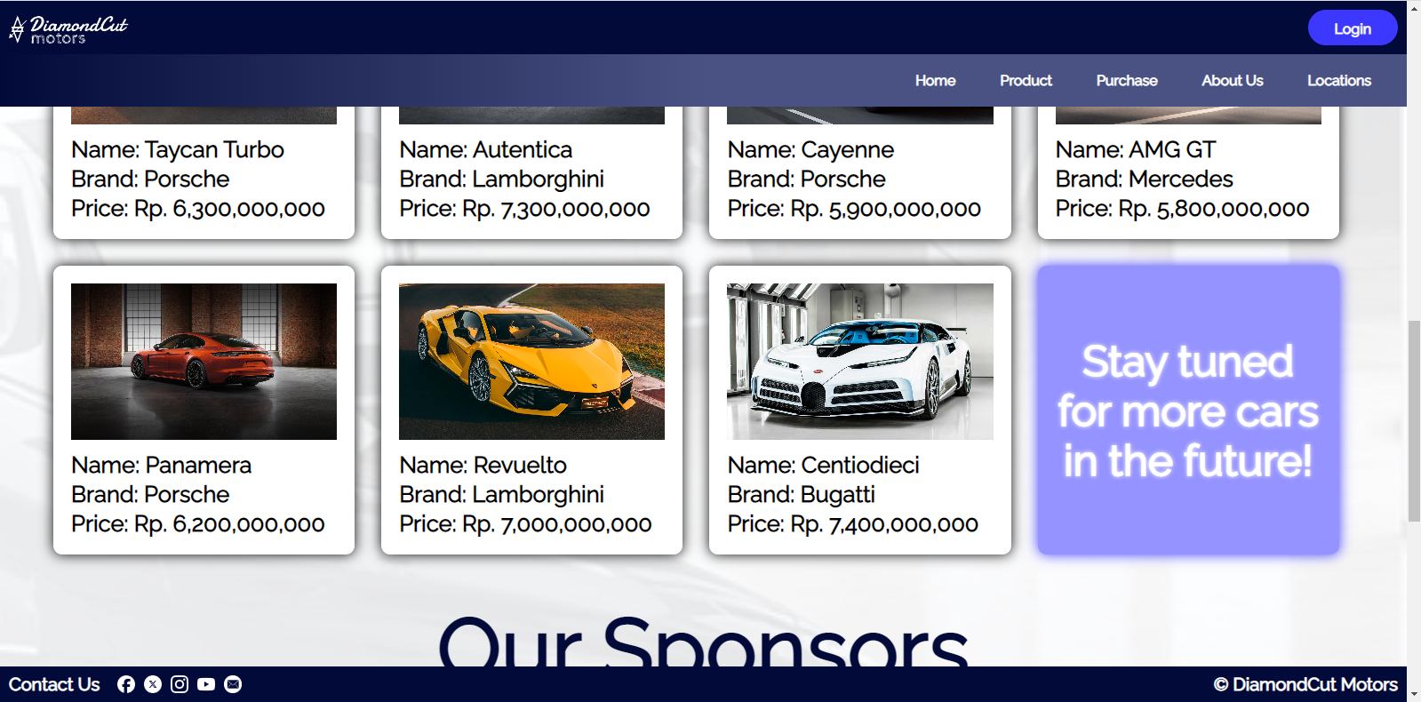

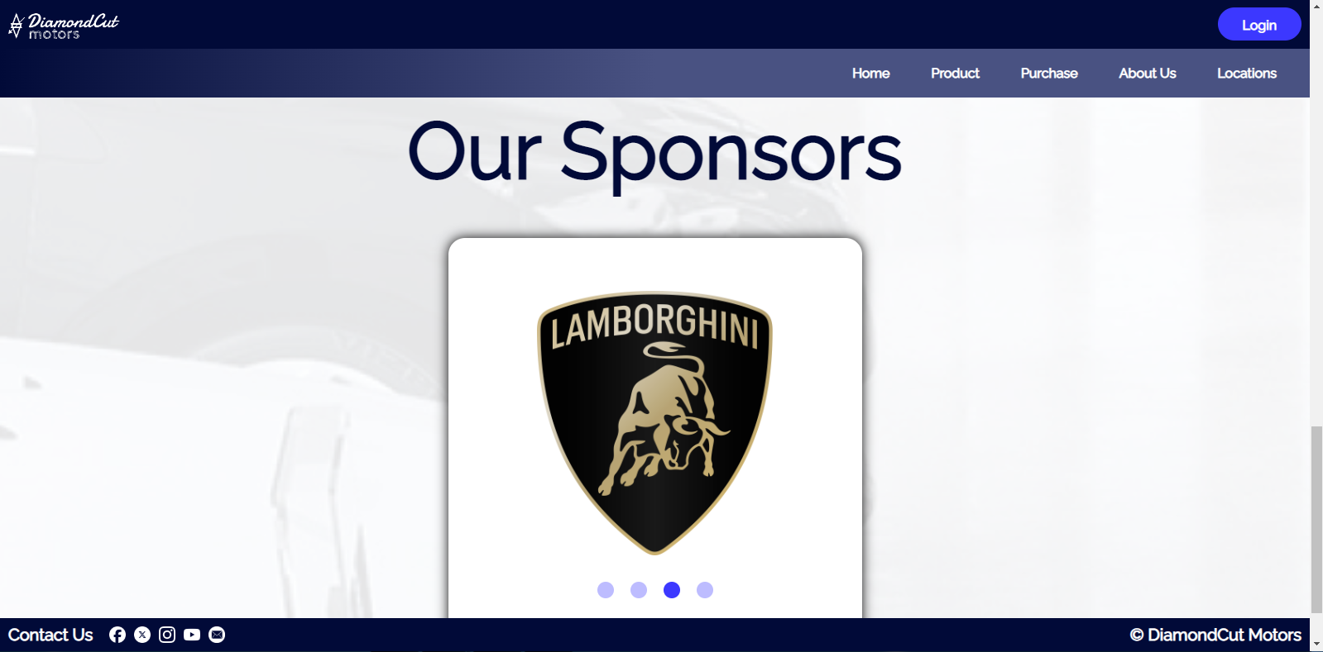

* **About Us Page**

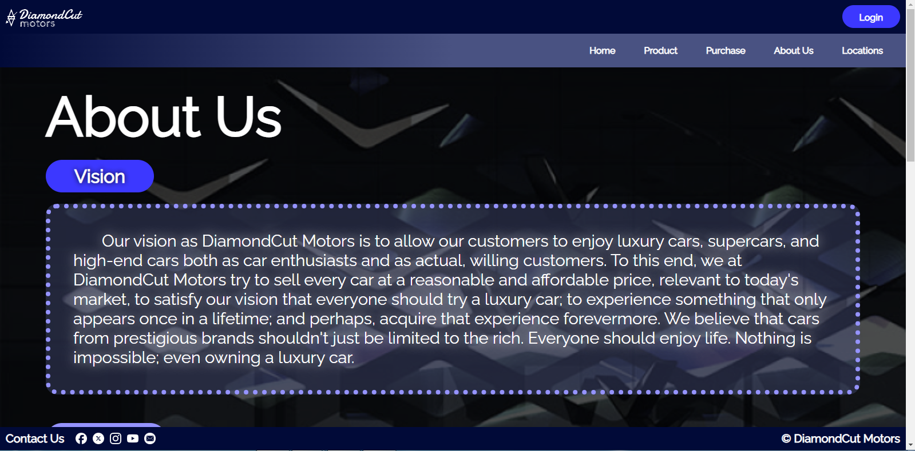

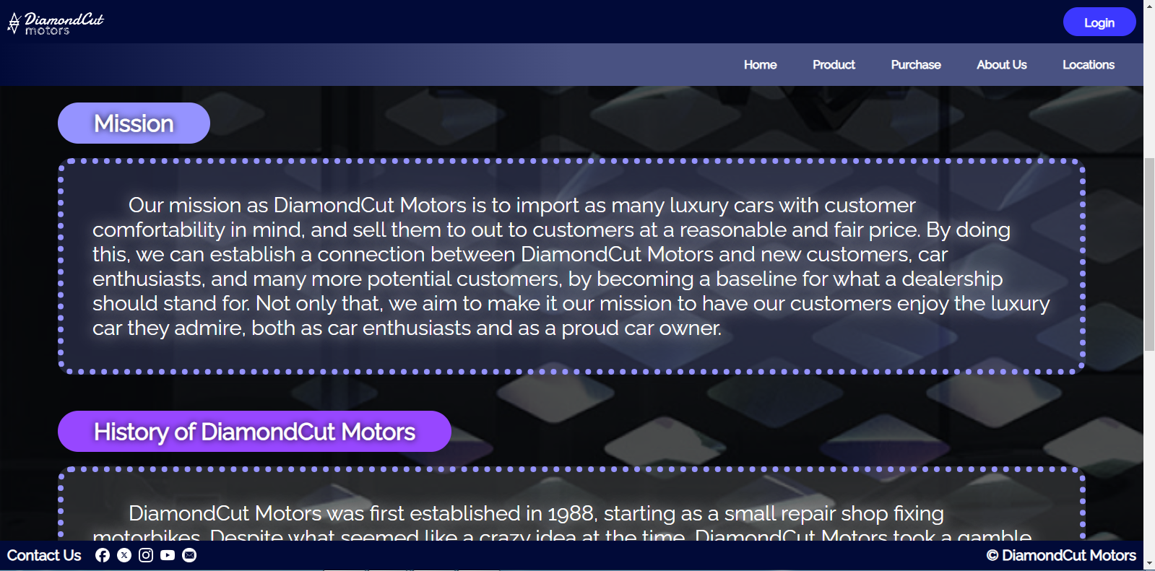

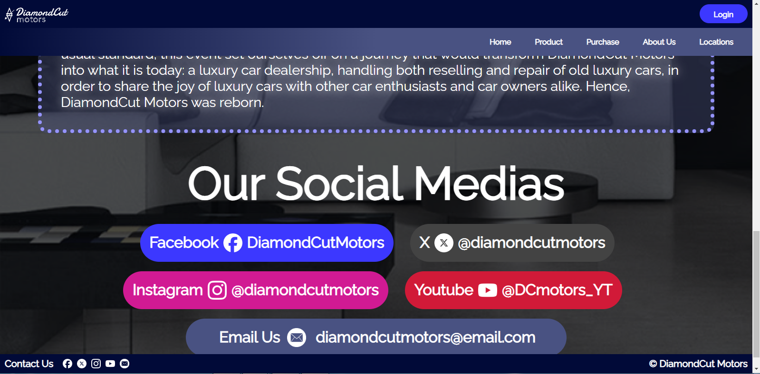

* **Locations Page**

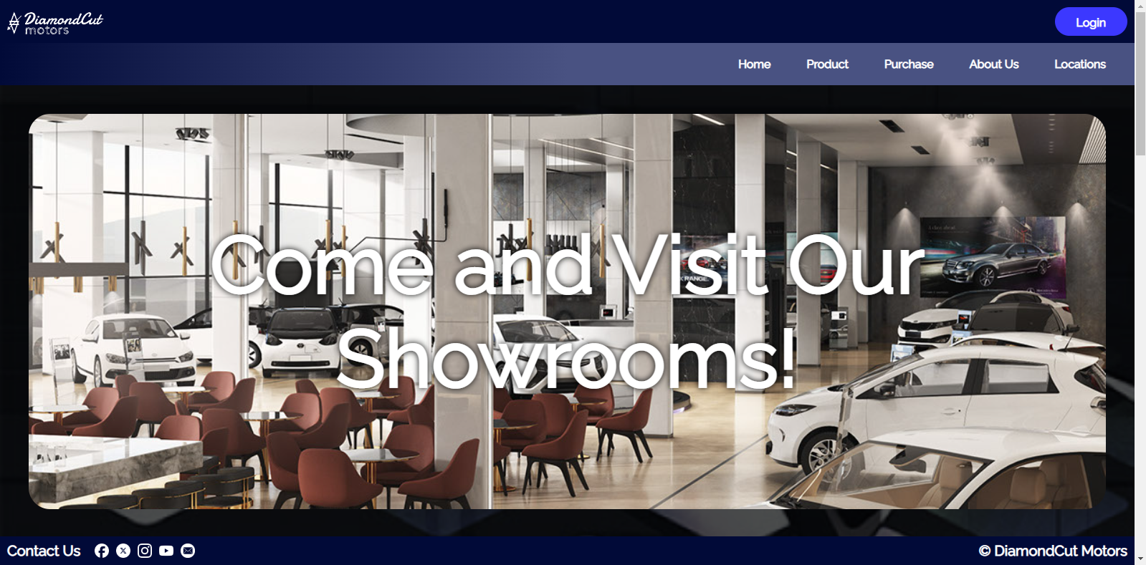

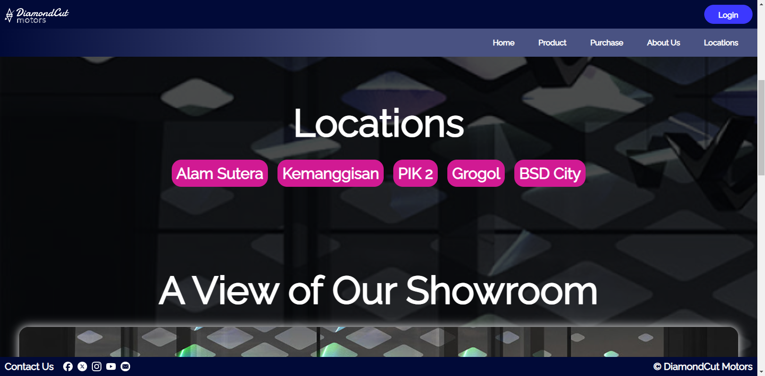

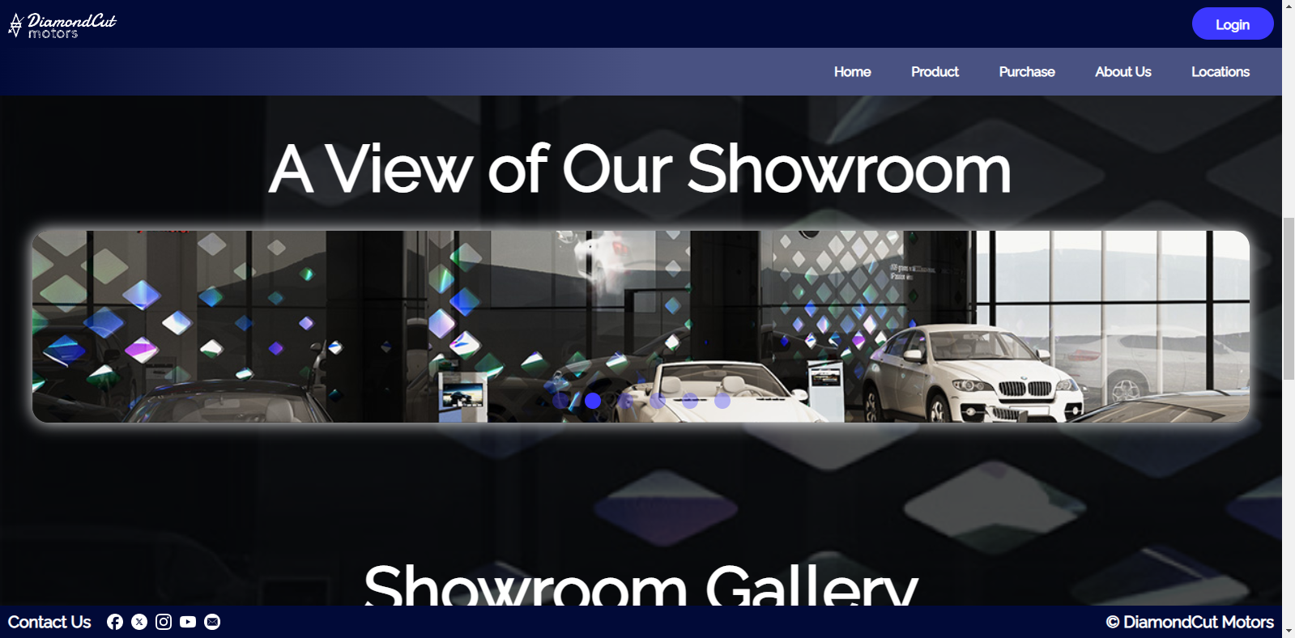

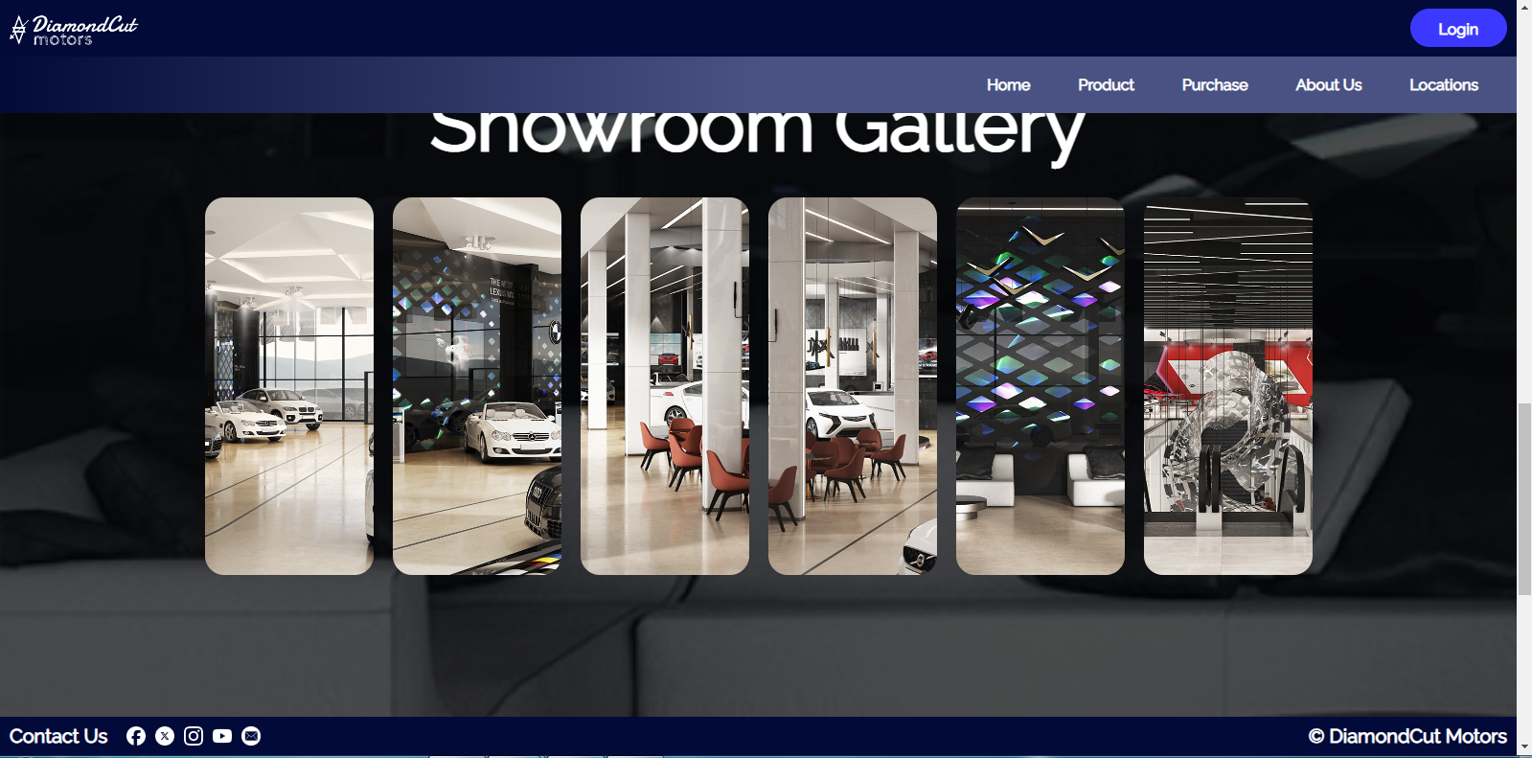

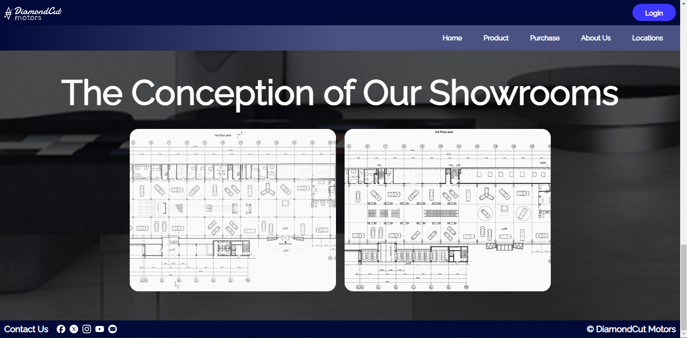

* **Login Page**

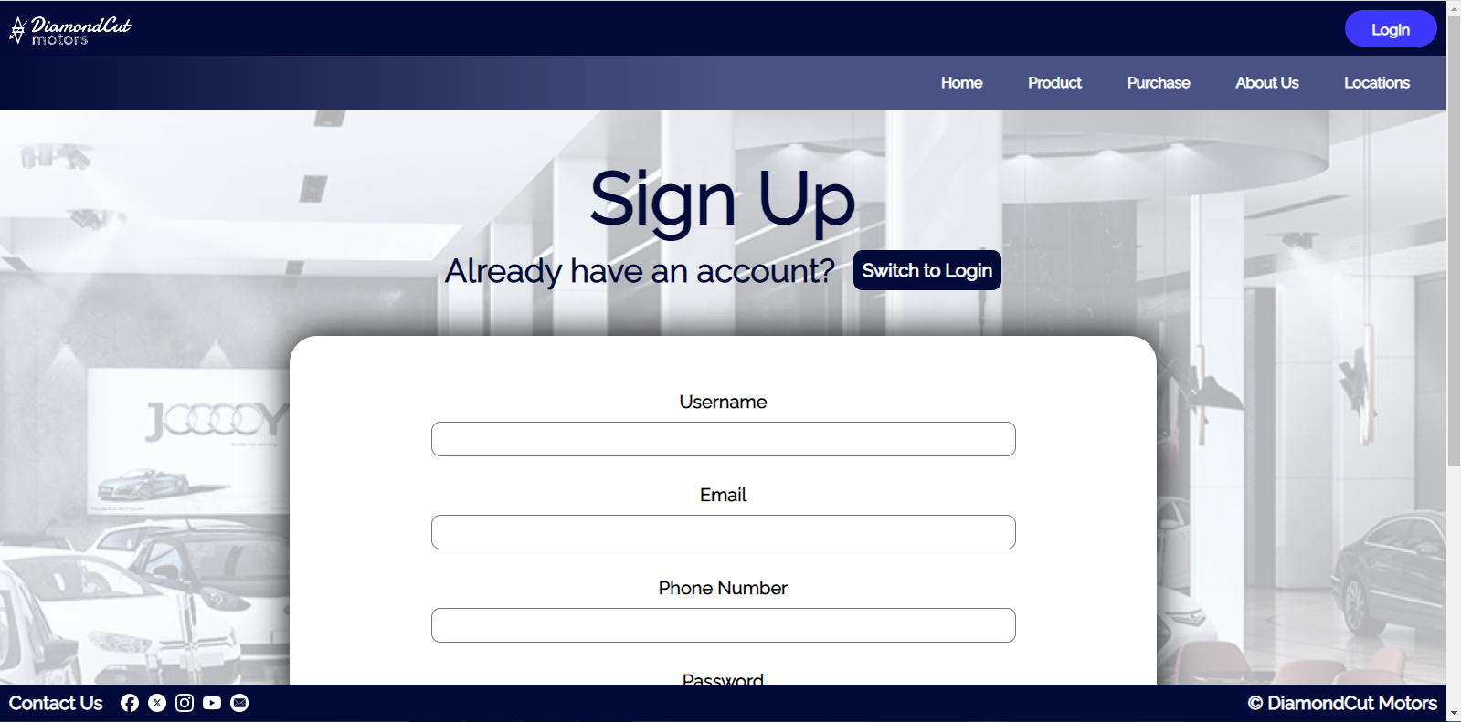

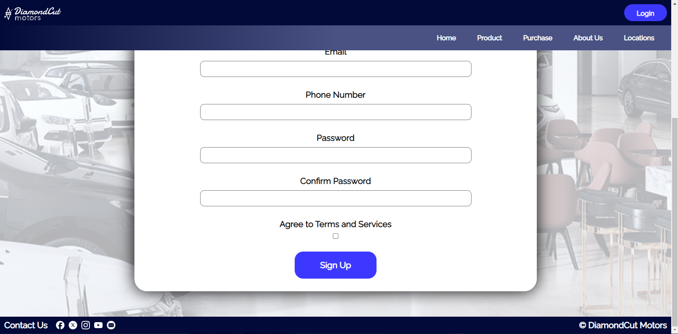

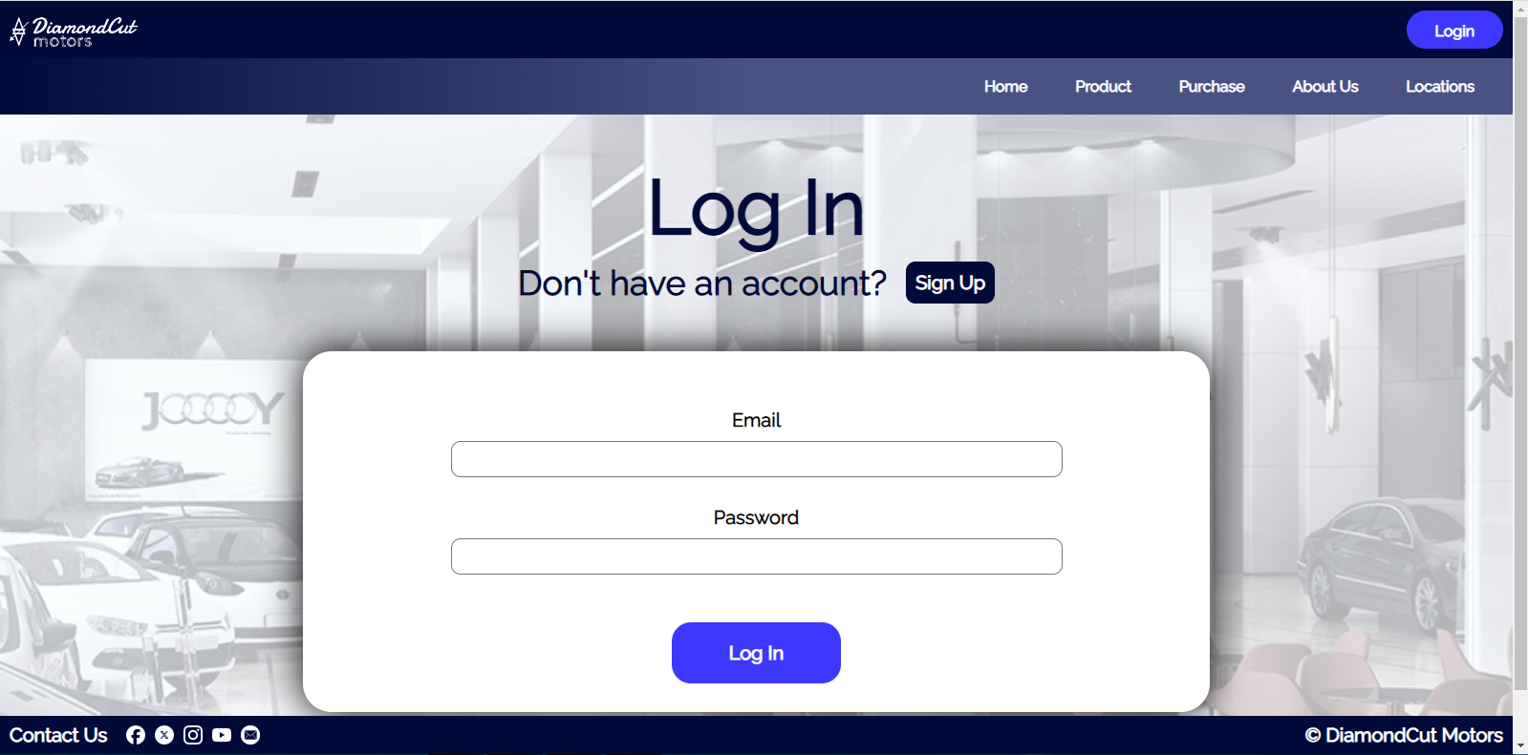

**Asset Link References**

“DiamondCut Motors” Logo: Made by myself on Figma, original shapes on the Figma file.

“Enlarge” Icon: Made by myself on Figma, original shapes on the Figma file. This wasn’t used on the actual website coded, but is still visible on the Figma.

Left & Right Arrows: Made by myself on Figma, original shapes on the Figma file.

Lamborghini Revuelto (Yellow): <https://id.motor1.com/news/693721/lamborghini-cek-bahanbakarsintetis-stop-supercarice/>

Lamborghini Revuelto (Orange): <https://www.lamborghini.com/en-en/news/lamborghini-revuelto-the-first-super-sports-v12-hybrid-hpev>

Lamborghini Autentica: <https://id.motor1.com/news/651009/lamborghini-invencible-autentica-debut-v12terakhir/>

Bugatti Centodieci: <https://id.motor1.com/news/627354/bugatti-centodieci-terakhir-10-unit/>

Porsche Taycan Turbo: <https://id.motor1.com/news/715869/skunkworks-porsche-membangun-taycan-turbogt/>

Mercedes-Benz AMG GT: <https://www.topgear.com/car-reviews/mercedes-benz/amg-gt>

Porsche Cayenne: <https://www.porsche.com/pap/_indonesia_/models/cayenne/cayenne-models/cayenne/>

Porsche Panamera: <https://www.porsche.com/pap/_indonesia_/models/panamera/panamera-models/panamera-4-e-hybrid/>

Facebook Logo: <https://uxwing.com/facebook-app-round-white-icon/>

X (Twitter) Logo: <https://uxwing.com/x-social-media-white-round-icon/>

Instagram Logo: <https://uxwing.com/instagram-white-icon/>

Youtube Logo: <https://uxwing.com/youtube-app-white-icon/>

Mail Logo: <https://www.pikpng.com/downpngs/ihxJbim_email-icon-email-icon-round-white-png-clipart/>

Showroom Pictures (All): <https://www.behance.net/gallery/52937817/Car-showroom-SHAHR-KHODRO-interior>

Lamborghini Logo: <https://en.wikipedia.org/wiki/File:Lamborghini_Logo.svg>

Mercedes Logo: <https://commons.wikimedia.org/wiki/File:Mercedes-Logo.svg>

Bugatti Logo: <https://commons.wikimedia.org/wiki/File:Bugatti_logo.svg>

Porsche Logo: <https://en.wikipedia.org/wiki/File:Porsche_logo.svg>

**Application Description**

At it’s core, DiamondCut Motors is a website aimed to promote and sell cars, by enticing users to come to its showrooms. Users may mainly make use of this site/application by checking out the pictures of the cars within the entirety of the website, to which multiple products, locations, and information can be accessed to better further the user’s knowledge regarding DiamondCut Motors and its business. To this end, the website/application supports such features:

1. **Home Page**

In the home page, DiamondCut Motors provide a large, wide-screen gallery, which has two buttons; left and right. This allows the user to navigate the top tier cars of the company, which are also labelled with the car name and brand below. There is a giant text on the gallery, which informs and entices the user by briefly noting that the gallery contain top tier cars. Below that, a picture of the logo of the company is present, along with the company tagline: “Nothing is Impossible”. This immediately denotes to the user the goal and motto of the company. After this segment, a “Featured” tab shows a slider where multiple different kinds of cars the company is selling is shown on this slider.

The user may find a use in this page by viewing the potential cars they might like, by the top tier gallery segment or the slider on the bottom of the page. Not only that, they can also start to grasp the meaning of the company by taking a look at its tagline.

1. **Cars Page**

In the Cars Page, DiamondCut Motors showcases the multiple cars it has in its inventory, divided into two parts, which are “New Vehicles” and “Old Vehicles”. When the amount of cars end, there is a message detailing that more cars are to come soon. Below that, there is an automatic carousel that scrolls through all the brands which have collaborated with DiamondCut Motors and are sponsors.

The user might find a use in this page by taking a look at which cars are available and what state it is in, as well as the names, brands, and prices of each of the cars. Not only that, they can also view which companies can sponsored DiamondCut Motors in order to get a better idea of which cars are usually available for purchase.

1. **About Us Page**

In the About Us Page, DiamondCut Motors details its vision, mission, and history as a company in order to clarify the direction of the company as well as clear up any confusion the user might have about the company. This page also contains several social media links that are associated with DiamondCut Motors.

The user might find a use in this page by taking a look at the vision, mission, and history of the company in order for them to be thoroughly informed about the company and its motives. They can also access the social medias of the company in order to be better informed at to their workings and potential sales.

1. **Locations Page**

In the Locations page, there is a giant jumbotron used to entice and show the user what DiamondCut Motors’ showrooms look like, as well as invite them to come over to their showrooms. Not only that, this page also shows the locations that DiamondCut Motors’ showrooms are located. Below that, a carousel showing the interior of a DiamondCut Motor showroom is also displayed, which cycles through multiple pictures of the showroom. There also exists a showroom gallery, which provides a static view of the showroom with capability to enlarge if hovered in order to better provide the view that is unable to be seen in the carousel. Finally, there is a segment similar to the showroom gallery showcasing a showroom’s designs and plans.

The user might find a use in this page by viewing the showroom pictures, and getting interested in the showroom displaying the cars the company is reselling as well as denoting the countries in which DiamondCut Motors currently operates. Not only that, they can also view the showroom themselves in a better manner via the enlarged images, as well as see the plans of the showroom for themselves.

1. **Login Page**

In the Login page, there is a short text titled “Sign Up”, and below that, a query asking the user if they already have an account, along with a button. If the user presses this button, they will be moved to a login form. If the user clicks the button again, then they are moved back to the sign up form, which contains 6 elements to fill out and verified. This ensures that the user’s account details are checked and thorough in its making.

The user might find a use in this page by allowing themselves to make an account for the continued use of the website, in order to contact, purchase, and do many other things related to DiamondCut Motors. Not only that, the user can also login to their account if they already have one.